Lab Evaluation

Total Score Possible: 70 pts.

Each questions is 7 pts.

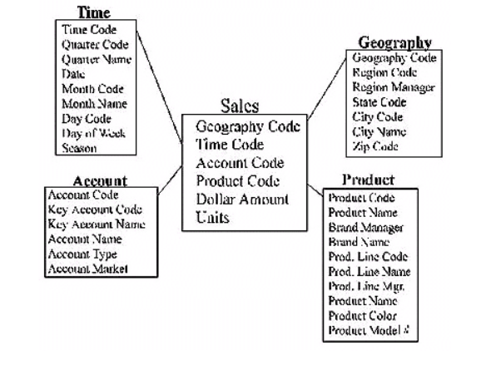

1. Does this schema represent a data mart or data warehouse? Why?
2. There are two predominant schema designs mentioned in the reading assigned for this lesson. Which schema is pictured above?
3. List the dimension table(s).
4. List the fact table(s).
5. List the columns that tie information between the tables. (Key columns)
6. List the measure columns.
7. What is the granularity of data? Explain your answer.
8. What is an example of a business question a manager might ask that this schema is designed to answer?

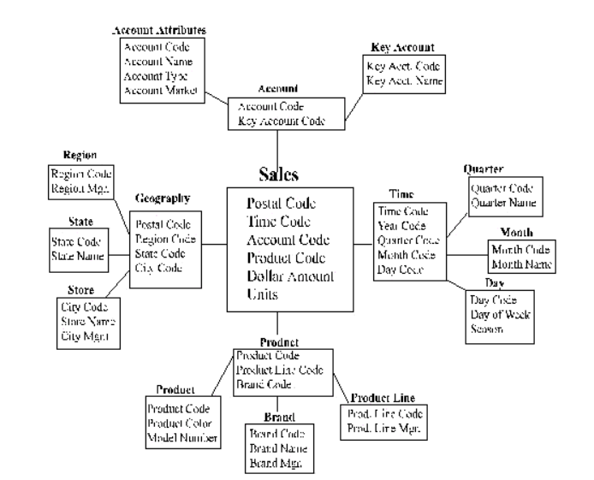

1. Is this schema more normalized or denormalized than the one on the previous page? What is this type of schema called?
2. Between the model on the previous page and the model on this page, which is more narrative? That is, which model more clearly and easily explains the data involved?